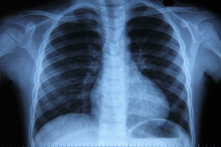 **PNEUMONIA STUDY** 



An Observational Study to Assess the Prevalence and Outcomes of Primary Pulmonary Coccidioidomycosis in Persons Aged >18 years Presenting with Community Acquired Pneumonia (CAP) in Endemic Areas (SAnds-PPC)



**You may be eligible for this study if you:**

* Are 18 years of age or older
* Have been diagnosed with pneumonia
* Have experienced flu-like symptoms in the last 28 days

**What is involved?**

* Attend up to 8 study visits over 24 months (2 yrs.)
* 2 “screening” visits
* 3 follow-up clinic visits and 3 telephone visits
* At the study visits, you will be asked to:
  + Provide information about your medical history, medications and treatments.
  + Allow study staff to complete a physical exam.
  + Fill out some questionnaires and surveys about your health, emotions, work and school.
  + Have blood drawn

**Qualifying participants receive:**

* Compensation for time and travel for completed visits
* Results of their blood tests for coccidioidomycosis

Whether you join the study or not, the medical care you receive from your doctor at Banner will not change.

*If you would like more information about this study, please call Alexandria Chaput at 520-626-8100.*

An Institutional Review Board responsible for human subjects research at The University of Arizona reviewed this research project and found it to be acceptable, according to applicable state and federal regulations and University policies designed to protect the rights and welfare of participants in research.